How to sideload MX-23 on a Orange Pi 5 (5 Plus, 5 Pro)

Background
Orange Pi 5 is a powerful and reasonably priced SBC (single board computer) produced by Shenzhen Xunlong Software Co., Ltd. At first glance it resembles the Raspberry Pi although there are many significant differences as explored in comparisons between the two (it also runs cooler than the RPi 5). Documentation and resources are good but the ecosystem is not strong—e.g., the Forum is difficult at best.
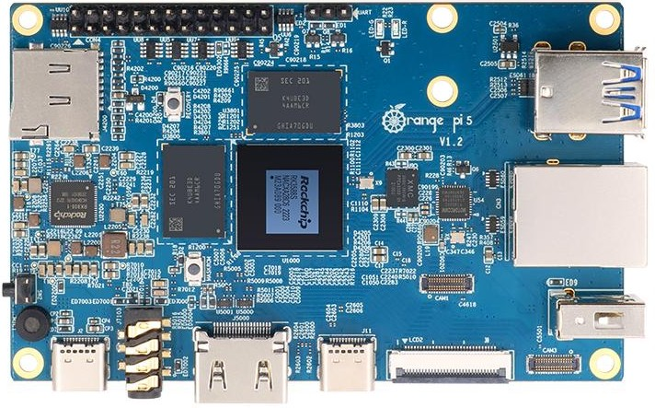

Preparation
1. Download and install the latest Orange Pi 5 debian_bookworm_desktop_xfce image from the official site. I used the Feb 2024 image in creating this how-to. [240517: Nov 2023 image]

2. Flash (MX Live USB or similar) the image to a good-quality SD card that is big enough (but at least 16GB) for your intended use. I used a 32 GB Samsung Pro.

3. Update (default password: orangepi): Menu > System > Software & Updates, “Updates” tab; or CLI:

sudo apt update && sudo apt dist-upgrade

4. Install at least LibreOffice Writer to avoid an error message later. You can use Menu > Settings > orangepi-config, “Software” for the whole suite; or CLI for just Writer:

sudo apt install libreoffice-writer

6. Remove conflicts:

--Uninstall oreangepi-bookworm-desktop-xfce to avoid a later conflict with an MX package. CLI:

sudo apt purge orangepi-bookworm-desktop-xfce

Note that this will remove the backgrounds of the login page and main screen.

--Uninstall pasystray to avoid later conflict with the MX sound setup

sudo apt purge pasystray

7. Enable the MX repo: click on the link this up-to-date page. You will need two items:

a. The MX-23 apt line. Here is the one that worked for me (different from what is given on that page which shows a trailing slash on the url):

deb http://mxrepo.com/mx/repo bookworm main non-free

b. The public key. There will be a copy in Documents after you extract the zip file. If not, follow the directions on that MX page or right-click the link “MX-23 public key” and save it.

Now that you have both of those, open Settings > Software & Updates again.

--On the “Other software” tab click the “Add” button and paste in the apt line you saved.
--On the “Authentication” tab, click the “Import Key File” button and navigate to where you stored that.

Click to close the app. Software & Updates will prompt you to update system information. Do that and reboot.

Basic Installation
1. Install

sudo apt install mx-packageinstaller synaptic mx-tweak user-installed-packages

Launch Package Installer > Popular Applications tab. Click on “Desktop Environments” and highlight Xfce. Click Install.

Once all that has finished reboot.

2. Set up the panel

Right-click the panel > Panel > Panel Preferences. Select Mode “deskbar”
Launch MX-Tweak > Panel tab. Click to apply: Restore default panel

Missing icons will be fixed in the next step.

Log out/in.

3. Get MX system software

a. Launch the app user-installed-packages and click the bar “Open a previously saved list etc.” Navigate to Documents/software and select the txt file there.

b. A list of any packages unable to be installed will be shown. There should be nothing there that affects MX or Xfce. Save that list for future use.

c. Proceed with the installation of the remainder, then log out/in.

4. Recommended (can be done later just as well)

a. change user password with MX User Manager if not done already.

b. right-click the desktop > Desktop Settings, change the source folder to “backgrounds” and select a wallpaper.

c. Click Menu > Settings > Keyboard, “Application Shortcuts” tab, and click the “Add” button.

Name: Drop-down terminal

Command: xfce4-terminal --drop-down

Basic Configuration
1. MX Tweak
a. Theme
Application: mx-comfort
Icons: papirus-mxblue-darkpanes
Window manager: mx-comfort
b. Config options
Select and apply: “Reset Thunar custom etc.” and “Enable single click in Thunar”
Log out/in and check.
2. Set correct time zone with MX Date & Time; use MX Locale to get a detailed setup (and to remove unneeded packages).
3. Updater
a. Copy two files from Documents:
mx-version
lsb-release
Use Thunar as root to paste them into /etc. Check that they are there.
b. Click Menu > Settings > Session & Startup, “Application Autostart” tab, and click the “Add” button.
Name: Updater
Command: apt-notifier
c. Paste the file “apt-notifier.conf” from Documents into ~/.config/MX-Linux/
d. log out/in (reboot if necessary)
4. Conky
a. launch mx-conky to import the themes to the Home folder, then close.
b. launch conky-manager to select a conky (default MX-Cowon_MildBlue_temp)
c. Click Menu > Settings > Session & Startup, “Application Autostart” tab. Click the “Add” button, and enter
Name: Conky
Command: sh .conky/conky-startup.sh
5. Login screen
a. delete as root the existing /etc/lightdm/ folder
b. copy the folder “Lightdm” in Documents and paste it into /etc
c. reboot
6. Splash
The package plymouth-themes-mx should have been installed already. Run the following commands one at a time:
sudo plymouth-set-default-theme MXLiveLogo
sudo update-initramfs -u -k all

